All Middle School & High School Youth are invited to join us for a weekend they will not forget. A list of FAQs and important information is listed below.
All necessary forms and information can also be found on our youth page on our church website:
www.jupitermethodist.org
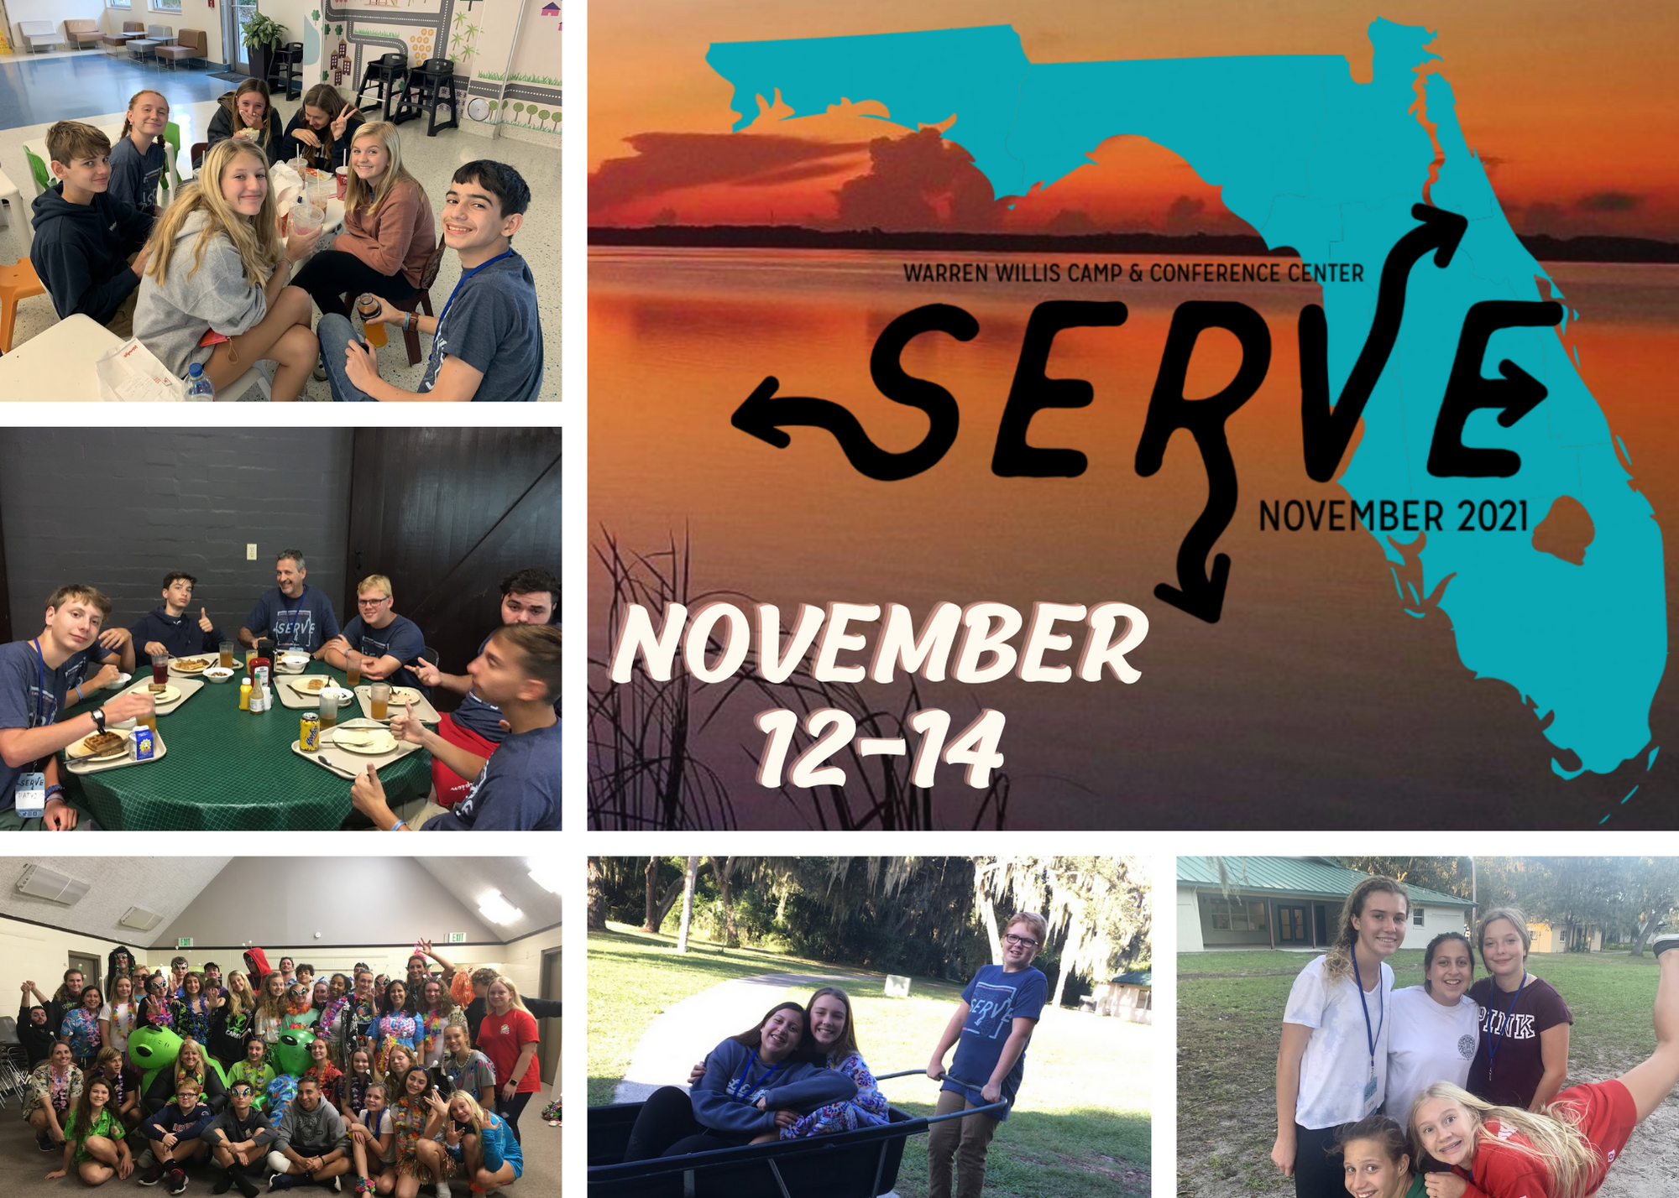

What, Where, When, & How Much?
Fall Retreat: Serve on November 12th – 14th. Warren Willis United Methodist Camp in Leesburg, FL. Cost: $160 and includes retreat, shirt, transportation (charter bus), supplies, and snacks. Each youth will be responsible for bringing money to purchase a fast food meal on the trip up and back.

Schedule
We will depart from the church on Friday, 11/12 at 5:00 PM and return Sunday, 11/14 at 3:00 PM. I understand this is a tight schedule for our middle schoolers. We will wait for all of you to arrive; however, we do ask that you come straight to the church in order to get us on the road as soon as possible.

Overview of the Weekend
Our Serve Weekend will offer opportunities for students to learn about serving their community, becoming closer as a community themselves, and providing a space for groups to come together and enjoy our campus. You can expect: awesome worship experience, hands-on workshops and learning experiences, space to connect with our group, and a weekend that will have your students talking for weeks.

Required for Registration (Due NO LATER than October 24th)
*Verbal Agreement ASAP
*Notarized Medical Release Form (available at church or online)
*2 Signed Camp Waivers (available at church or online)
*$160 Financial assistance is always available

Transportation
We will be traveling by charter bus. It is a 55 passenger bus equipped with a bathroom.

Sleeping Arrangements
The camp has several cabins throughout the property. All are cement buildings with AC and indoor bathrooms and showers. Girls and boys will have separate cabins with bunk beds for sleeping. You will need to provide your own sheets, blankets, pillows, or sleeping bag for the bed. Our adult youth leaders are in the cabin with the youth.

Dietary Restrictions
Warren Willis does an amazing job of providing meals for those that have dietary restrictions (vegetarian, dairy free, gluten free, nut free, etc.). Please just let me know so I can provide an additional form for you to complete for your youth.

Youth Leaders
We are required by the camp to have 1 adult for every 6 youth (same gender). A complete list of leaders will be available soon.

Packing List
Bible (if you do not have one please let us know and we will provide one), bedding, Towel, Toiletries (shampoo, toothbrush, deodorant, etc.), and snacks (only if they want to), flips flops are fine for day to day fun or being in cabin but they will be required to have tennis shoes/close toed shoes (not crocs) for some of the outdoor events. REUSABLE WATER BOTTLE.

Cell Phones – TBD

COVID RESTRICTIONS
A complete list of safety precautions is posted on our church website (youth page then click forms). MOST IMPORTANT PIECE TO KNOW: If your child was directly exposed to someone testing positive or DOES NOT FEEL WELL, please do not attend the retreat. Kelly will be taking temperatures prior to entering the bus. We are doing this step because they will also be performing temp checks upon arrival. If your child’s temp is 100.2 or above they will not be allowed to attend. That would be a long drive for our parents to come and pick up their youth. Pump the vitamin C & D and let’s keep them healthy for a great weekend away.

Church Snaps
This is a free and private way for us to share all of the pics and video from our weekend together. Like other social media, you can like, comment, or save any of the pics of your child to your own device. If you would like to view the pictures, copy this link and follow the instructions: https://churchsnaps.com/i/M958NTDB

For additional questions and/or concerns, please contact Kelly Betz at 561-309-5588 or visit the church website: www.jupitermethodist.org.

