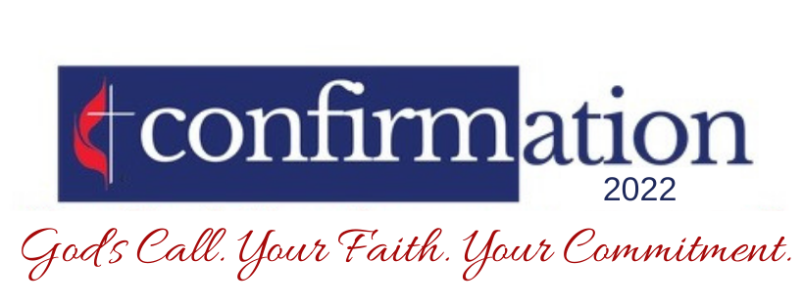

CLASSES:
2/20, 2/27, 3/27, 4/3, 4/24
10:30 AM – 12:00 PM
Will immediately follow our weekly youth time in chapel

CONFIRMATION WEEKEND
Friday, May 13th:
6:30 PM – 7:00 PM Parent Meeting
7:00 PM – 9:00 PM I Am the Church
Sunday, May 15th:
Confirmation Sunday @ 9:30 AM

Confirmation is open to all youth ages 6th – 12th grade.
Participants are highly encouraged to attend all the activities listed above.

